Dear CanSkate and Pre CanSkate Parents/Guardians:
Welcome to the 2022/23 CanSkate and Pre CanSkate program at the Uxbridge Skating Club. We are looking forward to seeing all of our skaters back on the ice soon!
Please note all COVID-19 protocols are lifted:
- Wearing of masks/face coverings is no longer mandatory in the facility, optional only

Skaters attending our sessions will have more fun and advance faster if they are properly and safely equipped. Please make sure that the following is ready for your first day:
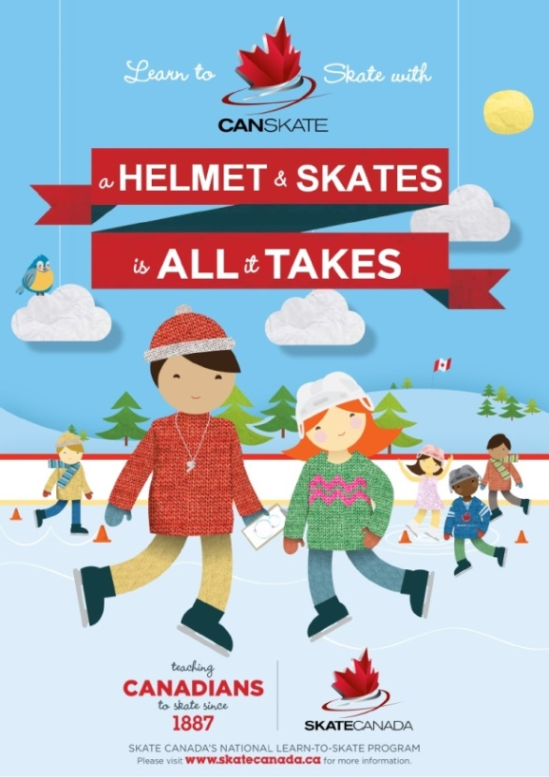
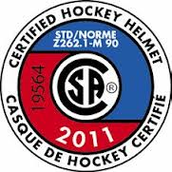
- Skates fit comfortably. There should be room for toes to wiggle slightly. Heels should not lift inside the skate more than ¼ inch. An adult finger should fit in the top of the boot when done up. Please tuck in excess laces or tie up laces so that they do not hang loose or drag on the ice. Sharpen skates if necessary.
- A CSA approved HOCKEY helmet with a chin strap MUST be worn by all skaters at or below Stage 5. Bicycle and ski helmets are not allowed.
- Skaters should dress warmly for their session. Most new skaters wear snow pants and a fleece jacket or a winter coat.
- Layering is a good idea.
- Please provide mittens or gloves for skaters to wear. Some items such as long drawstrings, scarves, dangling coat belts, etc. can be a hazard on the ice and should be avoided if possible.
- Some skaters may benefit from knee pads but be sure that the skater can bend in them. They will need to bend their knees to get up and down.
After you arrive at the rink check the main lobby for what dressing room you may use. Then please head to the lobby of pad one. For every session there will be a table set up with name tags. Please locate your name tag(s) for your skater(s). Attach this name tag to your skater(s). We will collect the name tags each day prior to your skater(s) leaving the ice. If you find the name tag still attached after your skater(s) has exited the ice, please place it back on the table.
CanSkaters will enter the ice at the lobby end and Pre CanSkaters will enter at centre ice doors. From there the coaches and program assistants will guide your skater(s) through a warm up and then to their groups. Now it is your time to relax while we take care of the rest. Once the session is over please pick up your skater(s) at the same door they entered.
Please feel free to contact the club with any questions or concerns. We are here to help.

